**Mr. Visca’s: Calculus (Chpt 3.2)**

**Chpt 3 – Day 2: Differentiability**

**3.2 Differentiability**

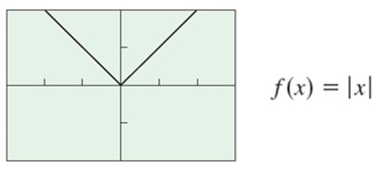How f’(a) might fail to exist:

1. _______________, where one sided derivatives ________________

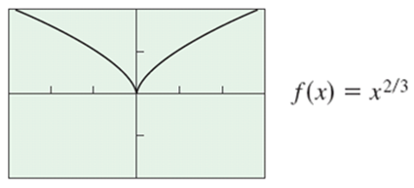

2. _______________, where slopes of secant lines approach both

_______ from one side, and ________ from another.

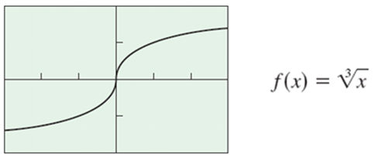

3. A ____________________________, where slopes of secant

lines both approach _________ or _________

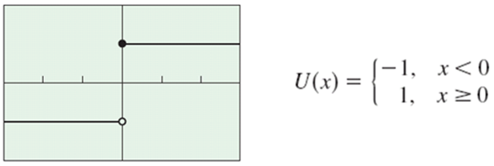

4. A ________________________, (one or both sided derivatives

don’t exist).

**Local Linearity**

A function is differentiable at a point if it is __________________.

(It look like a ____________ if you zoom in close) to that point.)

1. Graph, y = *x* cos 3*x*, and zoom in at x = 2.

Conclusion:

2. Graph, f(x) = |x|, and zoom in at x = 0.

Conclusion:

**Theorem**: If a function is __________________ at a given point then

it is _________________ at that point.

**Note that the converse is not always true.**

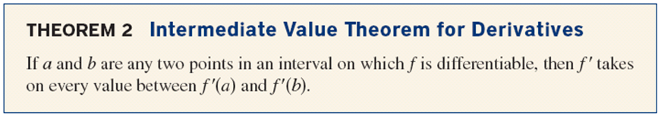



Numerical Derivative

*f(x)* = *x*2

Estimate *f* '(10)

NOW: Use the calculator to find *f* '(10), when *f(x)* = *x*2



1. Hit the "math" button

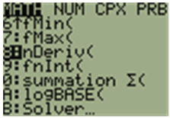

2. Option 8, nDeriv

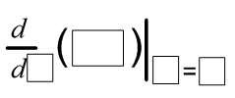

Note: the calculator uses a symmetric difference quotient,



this sometimes causes the calculator to give a wrong answer.

If nDeriv = 0, there may be a corner or cusp and derivative may not exist.

HW: Page 114

#s: 6-14, 18, 22-24, 31, 35, 39